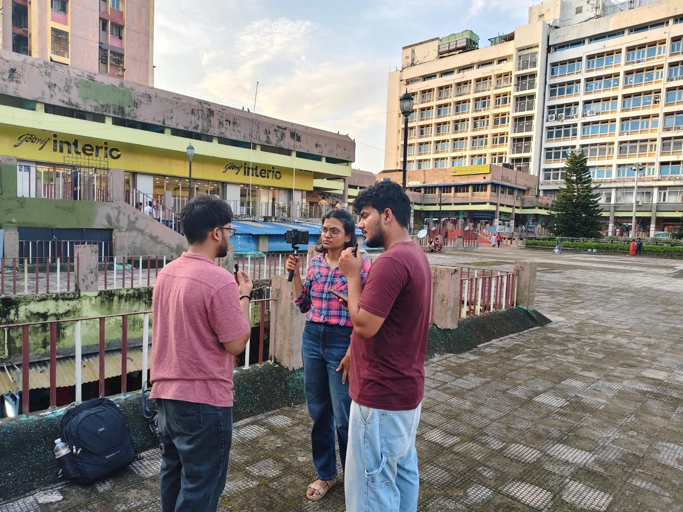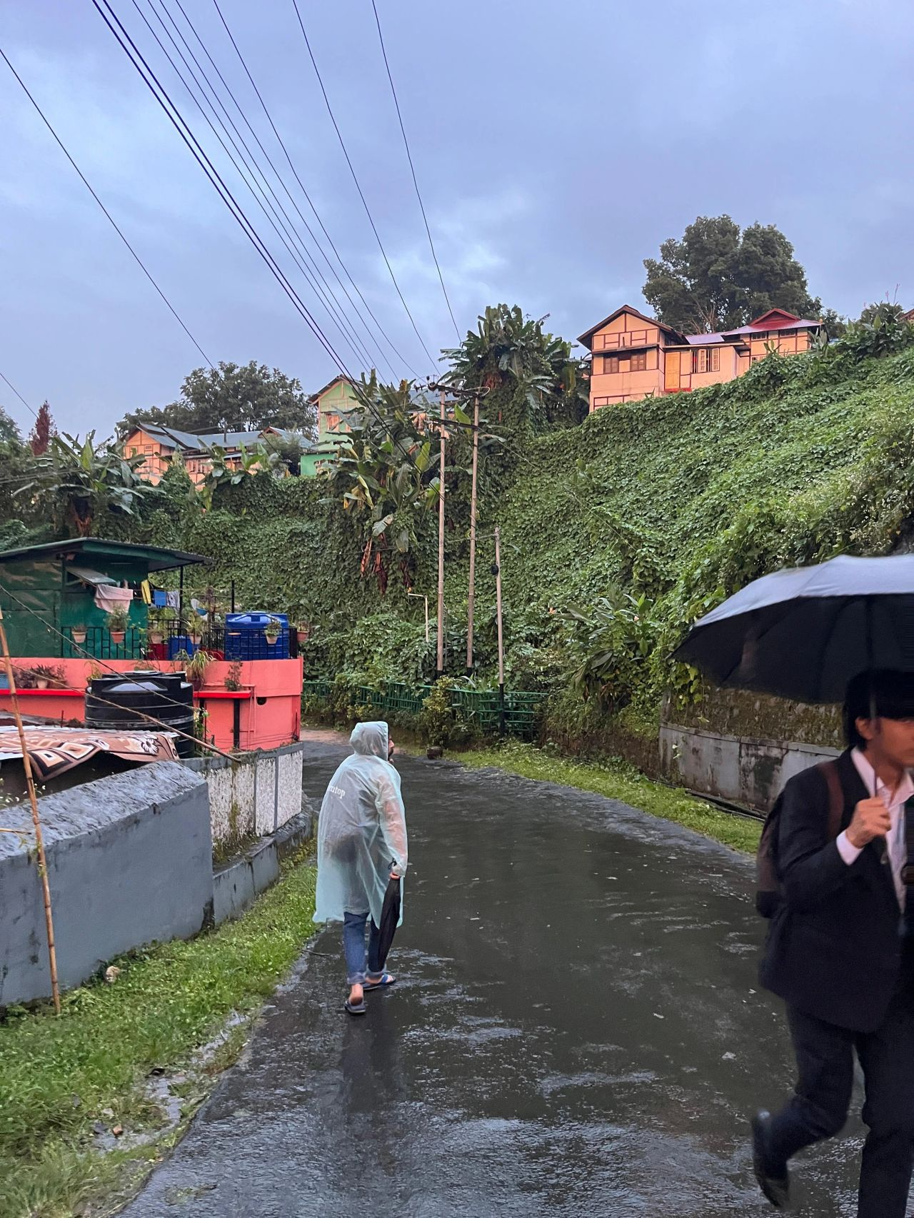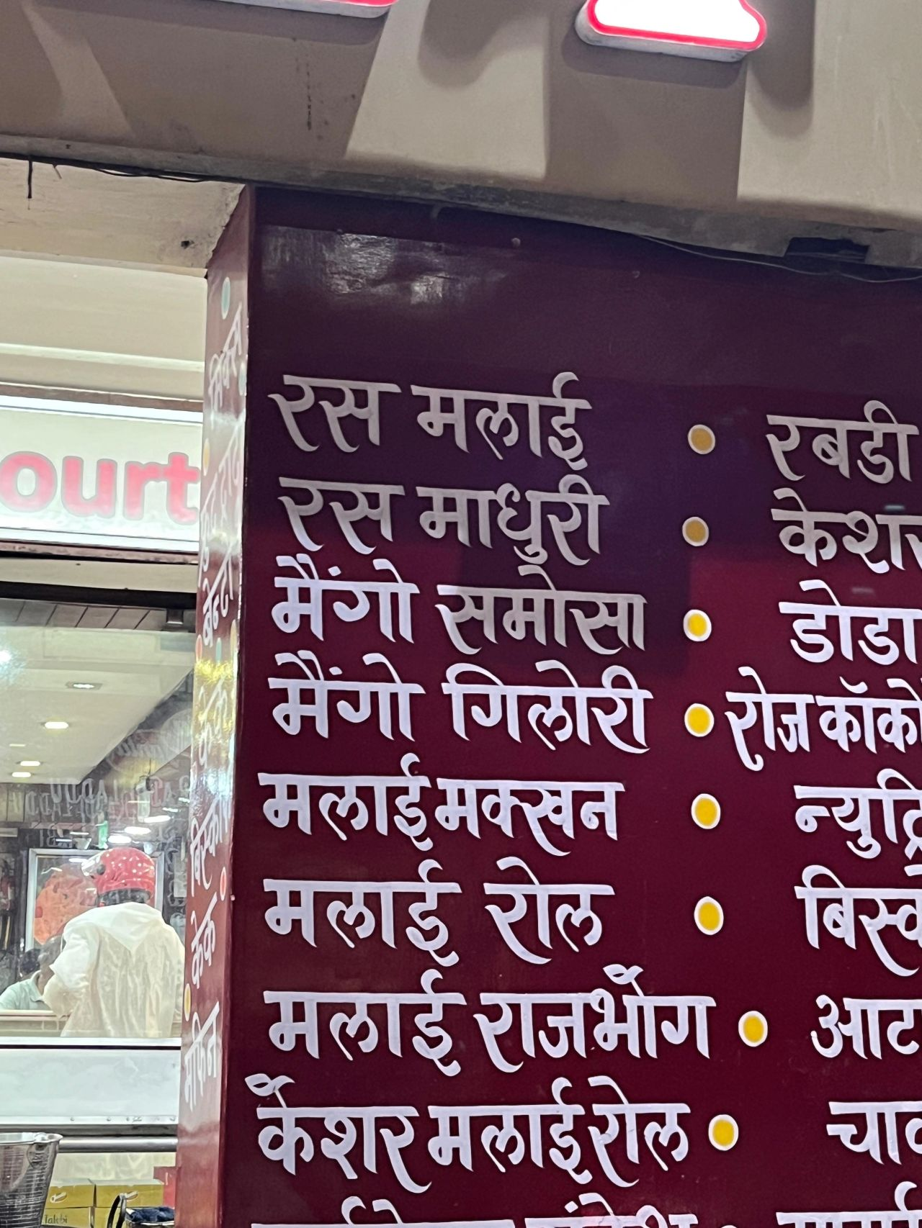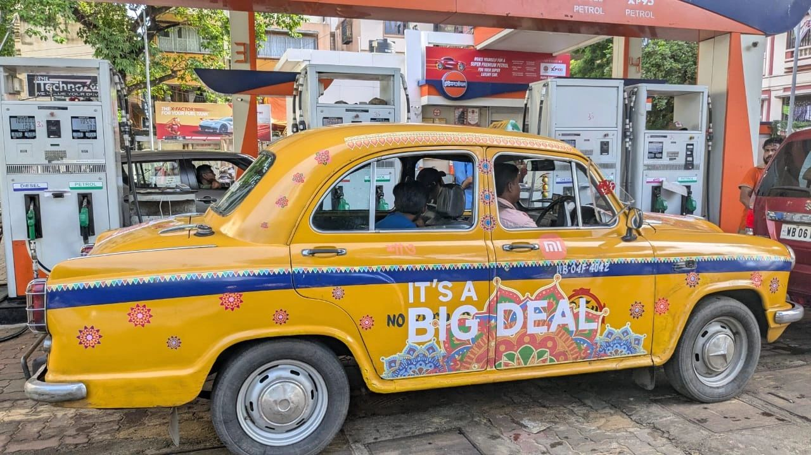

The idea of a time machine has always fascinated me.

The idea of devices that could communicate through time was even cooler.

Team 1001 Stories stayed in 15 cities, talked to 600+ people, surveyed city landscapes & markets, traced migration patterns, dreams, desires & the influence of native culture in the consumer psyche.

At some point, something interesting happened to all of us.

Our Idea of 2025, felt like a composite of 2015s, 2010s, the 2000s & parts of the 90s from the reference point of Bengaluru.

That is when we realised, India is not living through a singular 2025.

Itanagar gets excited at the idea of incoming Baskin Robins & KFCs.

Ujjain has figured very recently that newer colonies that allow for nuclear life are to be created.

Consumerism is at the cusp of acceleration.

But for now, Indore is where their desires are expressed.

Jodhpur, meanwhile, is trying to set up malls that just do not seem to take off.

Old world Marwari codes & bargaining as the rule of the market makes people not give in to fixed price set-ups.

They love their Starbucks & Dominos though.

In Prayagraj meanwhile, the metal made caricature of Captain Jack Sparrow is the coolest sight, as Justin Beiber's "Baby" plays in the mall.

All while the city's identity is undergoing a shift. Wondering which identity must dictate their regular life -

The Authority of Bureaucratic powers & Allahabad Highcourt, or the Saffron Sentiments of Prayagraj.

While Coimbatore figures becoming a new metro, holding its own weight against Chennai in the coming decade.

Kolkata is trying to figure out how to generate new opportunities with a history of having passed many by, anxious about losing culture but desperate for a grand revival.

While Mumbai, Delhi, & Banglore develop their own forms of what it means to be a metro, and what life in them looks like.

For anyone who has moved from tier 3 cities to tier 2, and tier 2 to tier 1 in India, this feels like the story of their life.

They've all experienced these memories, and have lived through them.

India is a Grand time machine.

To write the story of India, one has to understand each of these timelines, each of these 2025s playing out together.

